ECHTVENTURE website
Home
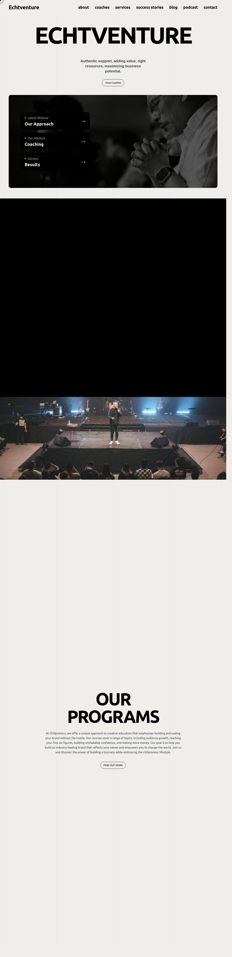
Enneagram Coaches Resources Contact
to add value to the businesses and lives we come in touch with.
We want to provide the right resources at the right time
to maximise our client’s potential
Our Mission
We believe in the progressive realization
of purpose and passion!


Our Process
Awareness to Mastery to Leadership
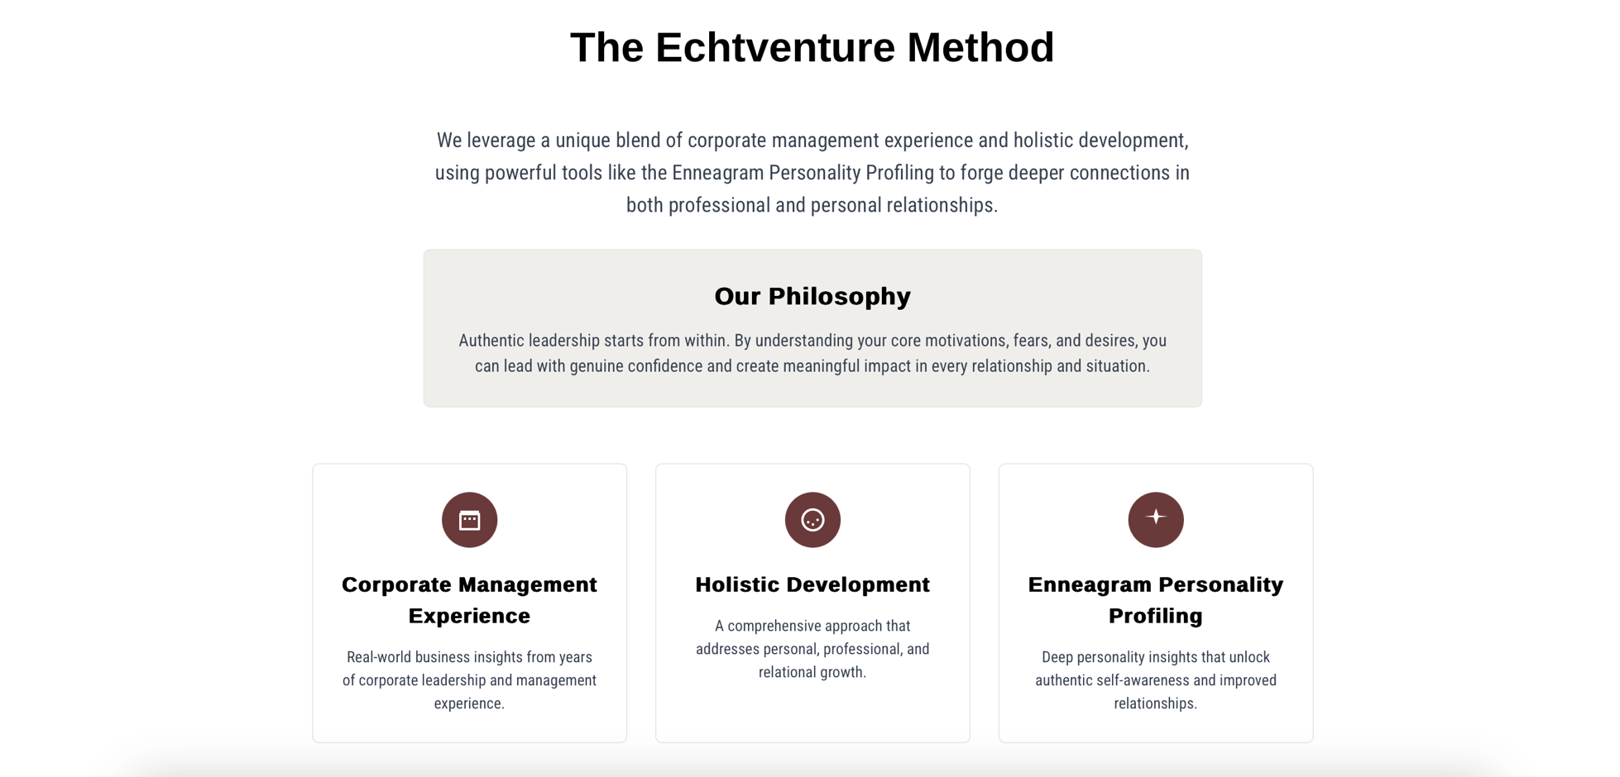

People We Work With
Individual Coaching // Group Coaching // Team Building

